Next week marks the most important week in our calendar – Parenting Week! From Monday 16th – Friday 20th October we will be sharing our messaging with one main aim – increasing the awareness of the support that is out there.

We have put together this social media asset pack to allow individuals and organisations to get involved on their own channels during the week by scheduling in these curated posts to their own channels.

Please take a few moments to post one or more of the below posts during Parenting Week. They can be copied and pasted directly on to Twitter, Facebook and Instagram. To add the accompanying picture, just save this document to the device you are on, then right click on the photo to save it, and then add it to the post as you would a photo on Facebook for example. We would really appreciate your help on sharing our messaging this Parenting Week 2023.

In addition to our posts, if you are creating any of your own content to mark Parenting Week, please do tag us and we will make sure to share.

Our social media handles:
Facebook: @parentlineni
Twitter: @childreninNI
Instagram: @parentline.ni

The hashtag we continue to use is #inyourcorner

Post 1:

This Parenting Week 2023, Parentline NI remind parents, carers and family members they are here and #inyourcorner. Whatever you are facing as a parent, Parentline offer a safe place to feel heard and are a nurturing space to help you make decisions.. We have no waiting lists and are here for your call. #parentingweek #inyourcorner

Picture to go with post:

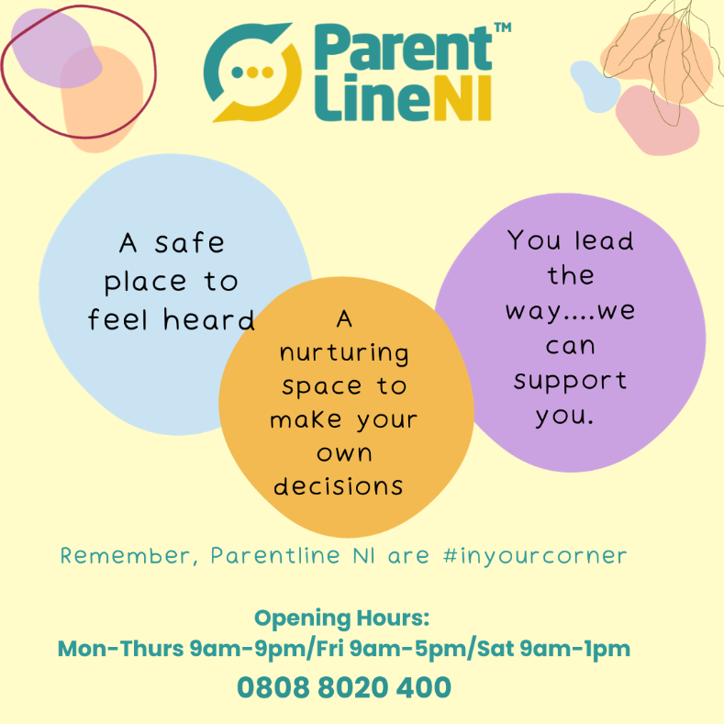

Post 2:

This Parenting Week, Parentline NI are aiming to increase the awareness of the support that is out there for parents. Check out a short animation on their services here https://youtu.be/9mqSWgPQGNs
#parentingweek

Picture to go with post:

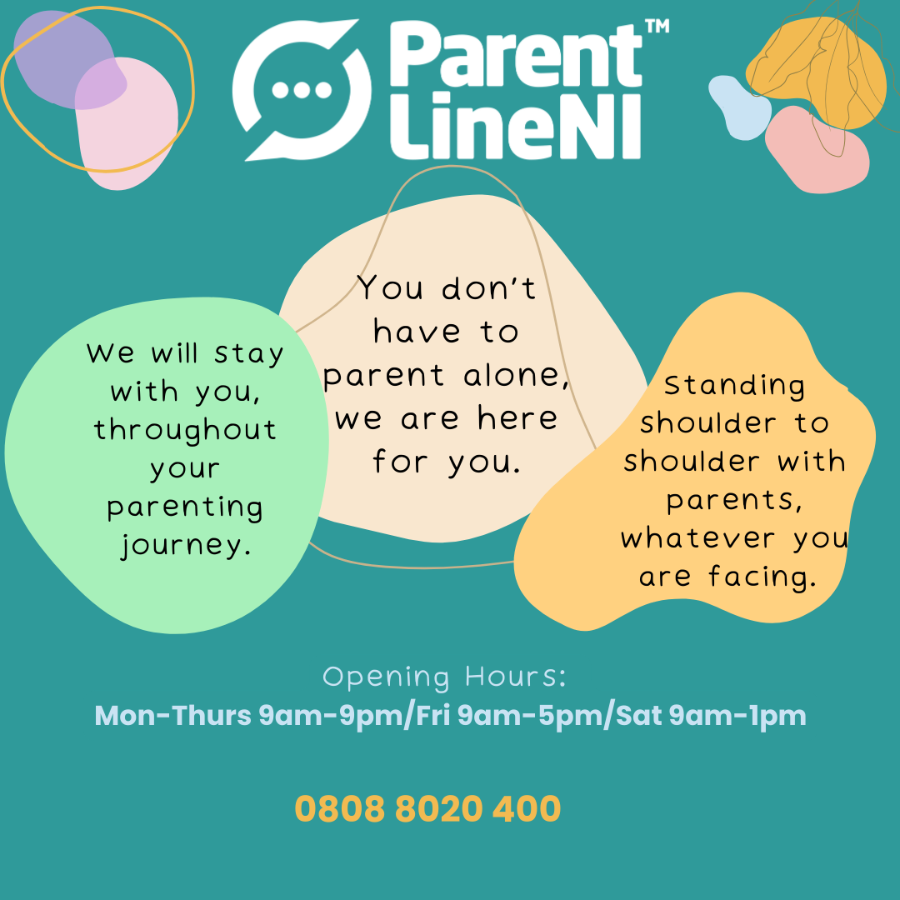

Post 3:
Getting help with parenting challenges always begins with a first step. We know it can be daunting to reach out for support especially if you are feeling unsure of which way to turn. Parentline NI are on the phone, webchat, or email to support you. You can also request a call back via our website https://www.ci-ni.org.uk/parentline/. Parentline are accessible, anonymous and accepting. Call 0808 8020 400. #parentingweek

Picture to go with post: (one or both can be used)

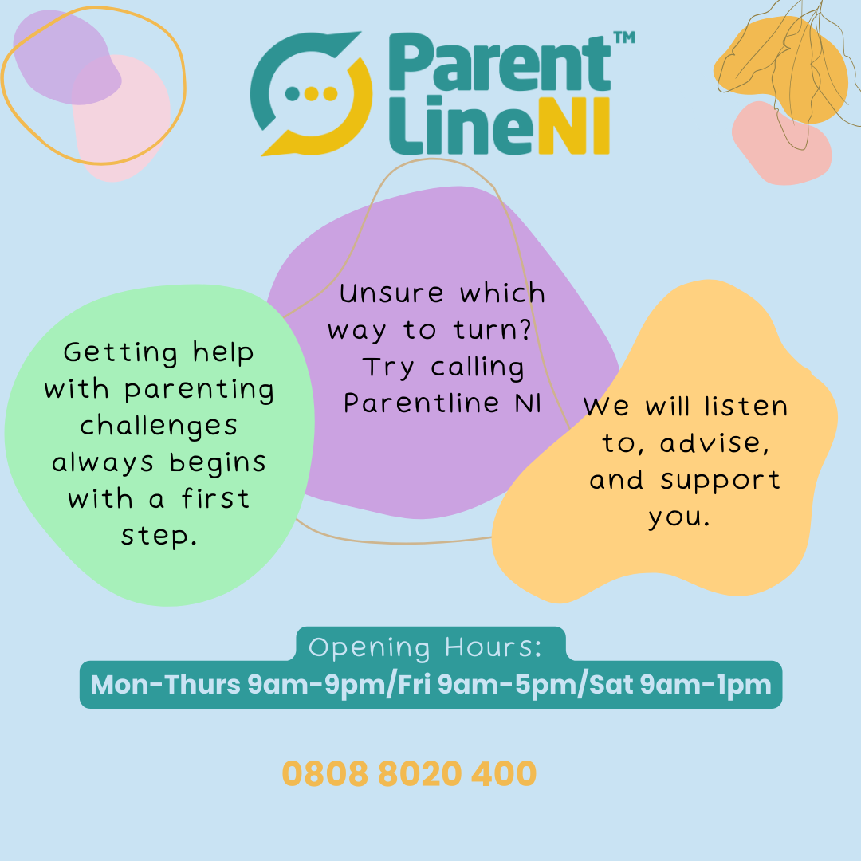

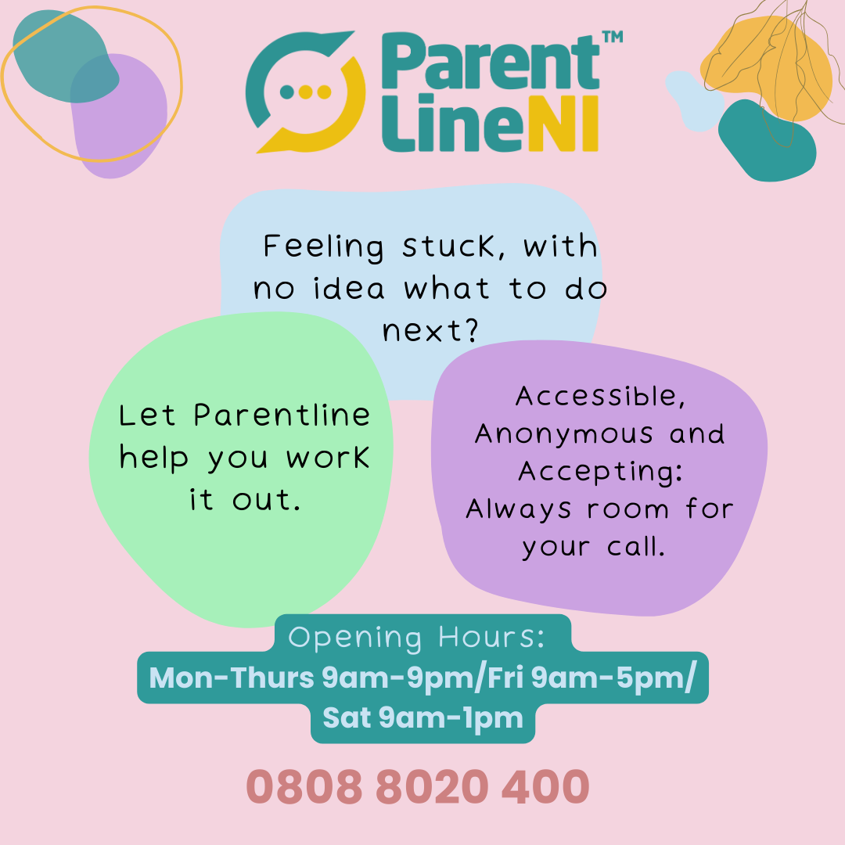

Post 4:
Do you work with parents or families? This #parentingweek, ParentlineNI are #inyourcorner and supporting parents together. The Parentline website has a bank full of resources available now to download and print as well as information on Parentline services and making referrals. Check out https://www.ci-ni.org.uk/parentline/ or call today on 0808 8020 400. Supporting parents together.

Pictures to go with post: (use one or more)
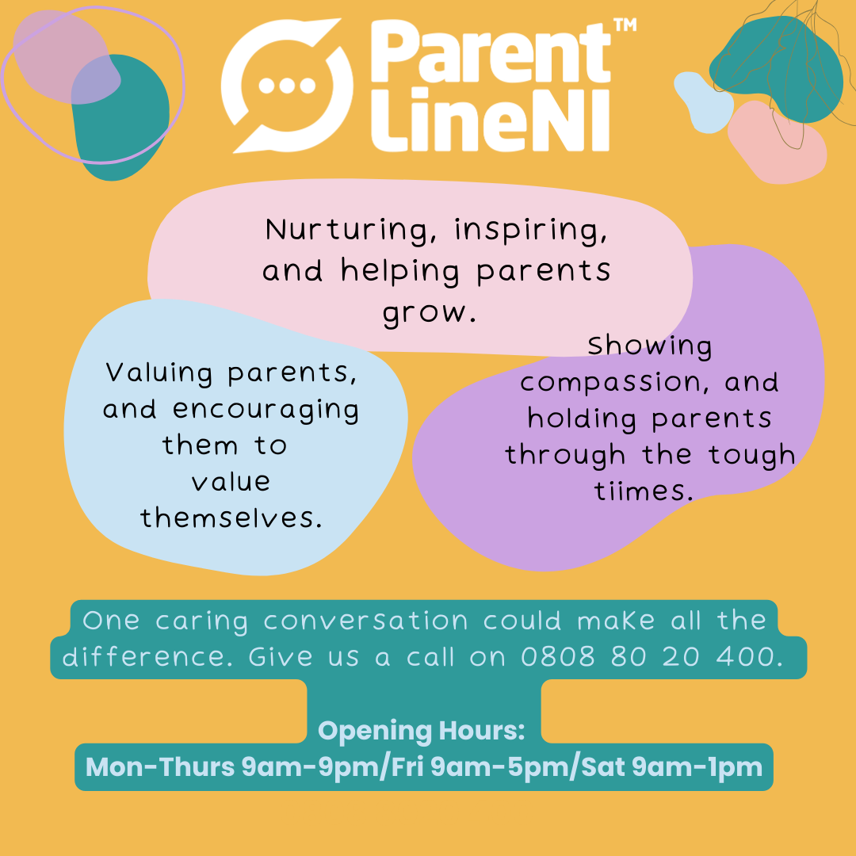

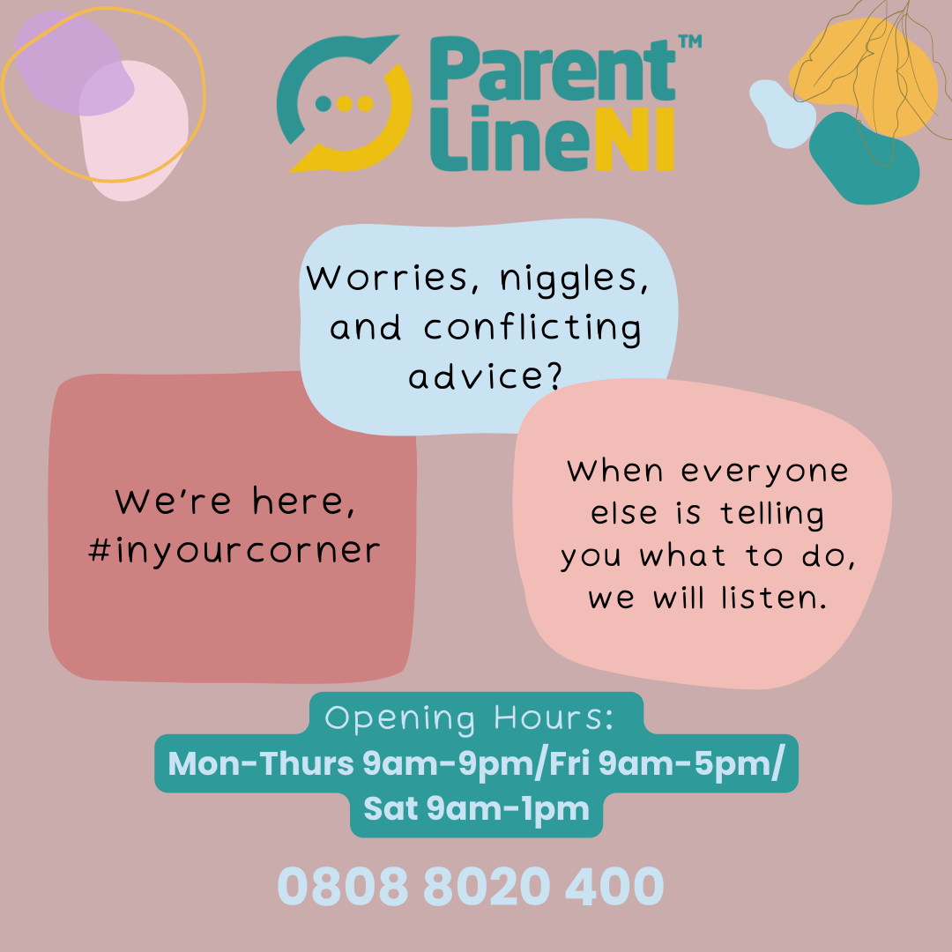

Post 5:
This #parentingweek, ParentlineNI are #inyourcorner. Are you stuck with strategies that don’t work? Open 6 days a week, our local, highly experienced Parent Support Officers can listen to, support and guide you. It’s free and confidential. Call 0808 8020 400, we’re here for you.

Picture to go with post:

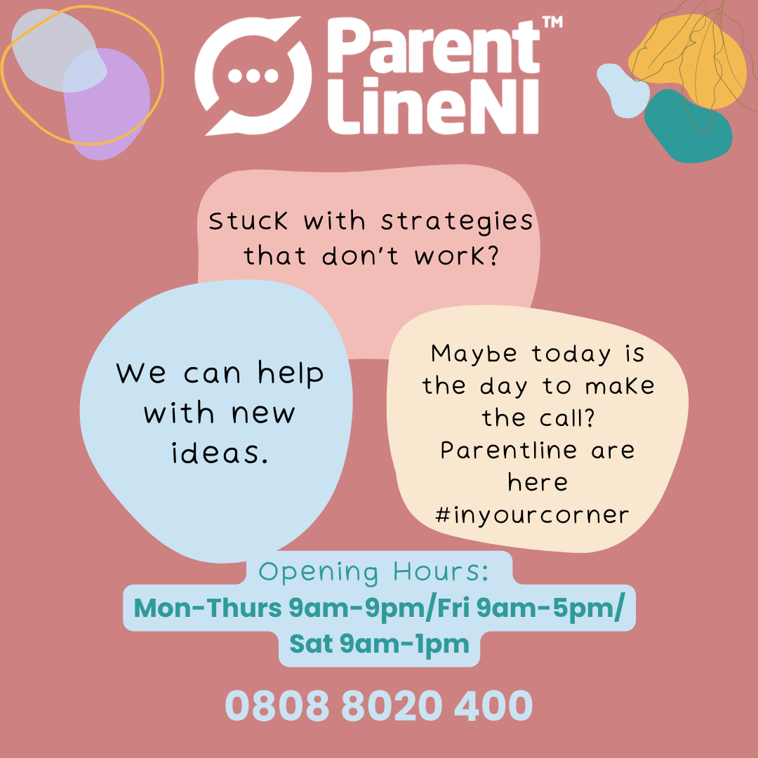

Post 6:
This #parentingweek, ParentlineNI are #inyourcorner, to talk about anything you are experiencing as a parent. There are no waiting lists, just a supportive, confidential space to help and support you. Call us today on 0808 8020 400, a compassionate, nurturing level of support is guaranteed.

Picture to go with post:

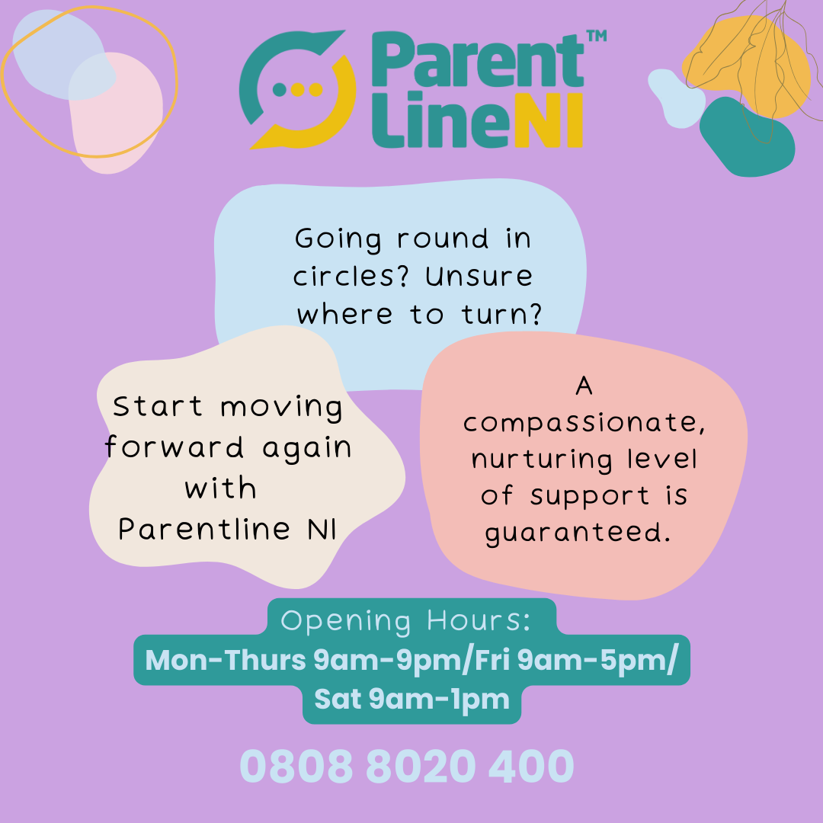

We hope you found these post ideas useful, and will get involved by scheduling some of them into your social media channels for Parenting week 2023, from October 16th-20th.

If you would like any more information/ resources, please contact Laurel Littlewood – laurel@cini.org.uk
or visit our website: https://www.ci-ni.org.uk/parentline-resources/

Thank you for all your help in promoting our service during Parenting Week 2023.

